This is a sample PaaS4SaaS application deployed in JCS-SX as an extension application to Oracle HCM.

After the setup , you can see a new icon present in HCM application Home page names “JCS Application Page” and on clicking it, our PaaS application gets opened. Note that SSO is being implemented here and hence you don’t need to login again. On PaaS application page, u can observe that the HCM employee name and all his details are being fetched and displayed.

Lets see the steps to be followed to replicate the same.

Develop the application using jDeveloper and build it. I have attached the war files to this document for reference.



Steps to deploy .war file in JCS-SX:

Log into JCS-SX instance following below steps:

1- <https://cloud.oracle.com/>

2- Sign in

3- Cloud account details   
    a) Traditional cloud account  
    b) EMEA commercial 2 em2

Then click my services.

4- **Identity Domain : hcuk**

5- Username : [amro.alfares@appspro-me.com](mailto:amro.alfares@appspro-me.com)

     Password : Appspro#123

     Login.

6- Click Java JCS - SAAS Extension.

7- Click Java Console.

It should look like this:

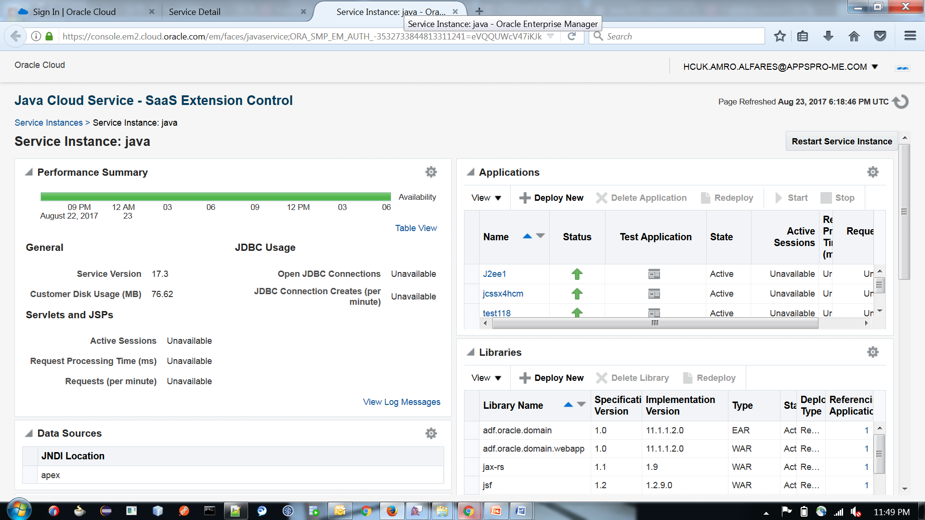

Click “Deploy New” and enter the name of the application “jcssx4hcm” and path to the .war file and click Deploy.

Then click on the link jcssx4hcm under Applications and note the URL down and click that to test it.

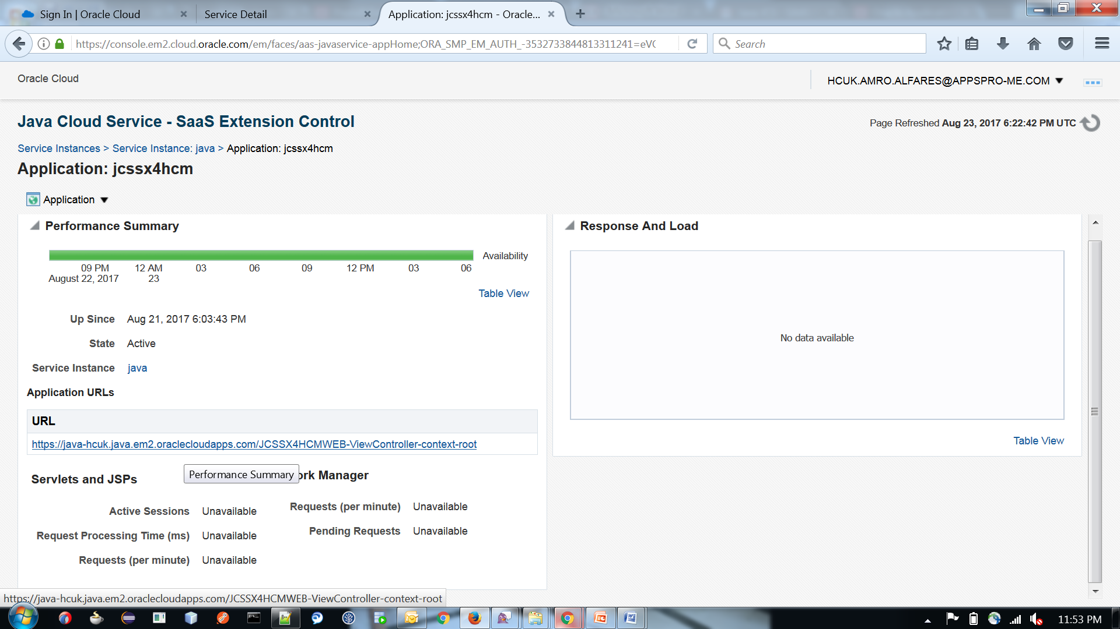

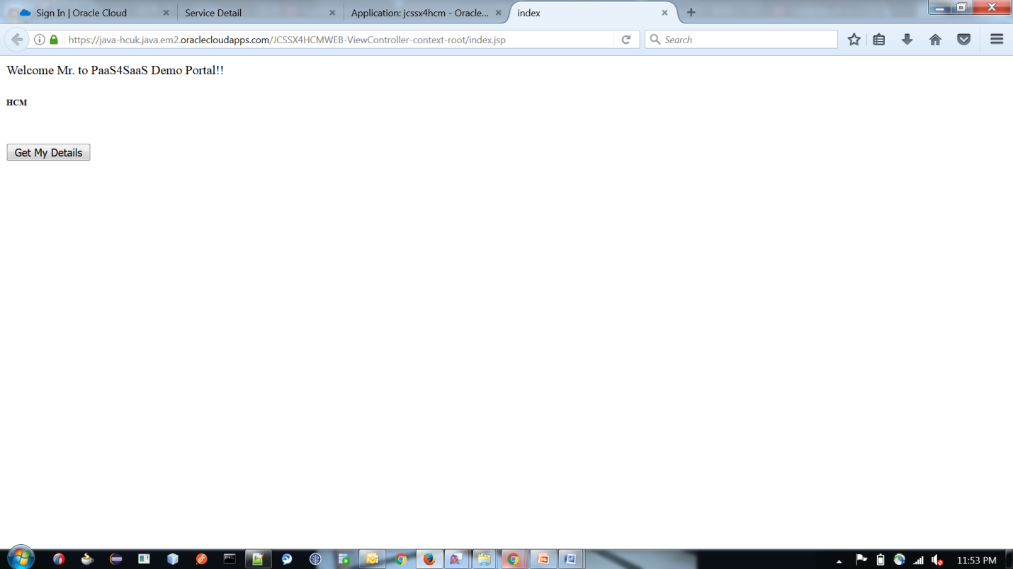

Steps to Configure HCM application:

Log into HCM with below details :

Application URL: <https://efgv-dev1.fs.em3.oraclecloud.com/homePage/faces/FuseWelcome>

The user name: **HCM_IMPL** and password: **Welcome@123**

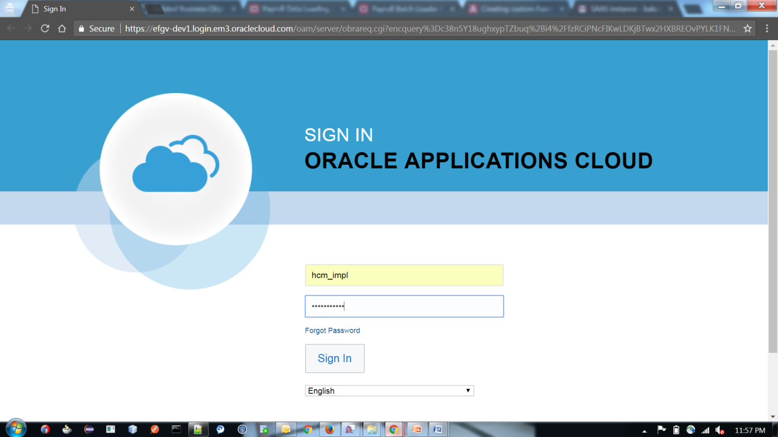

From Home screen, click on “Manage Sandboxes”

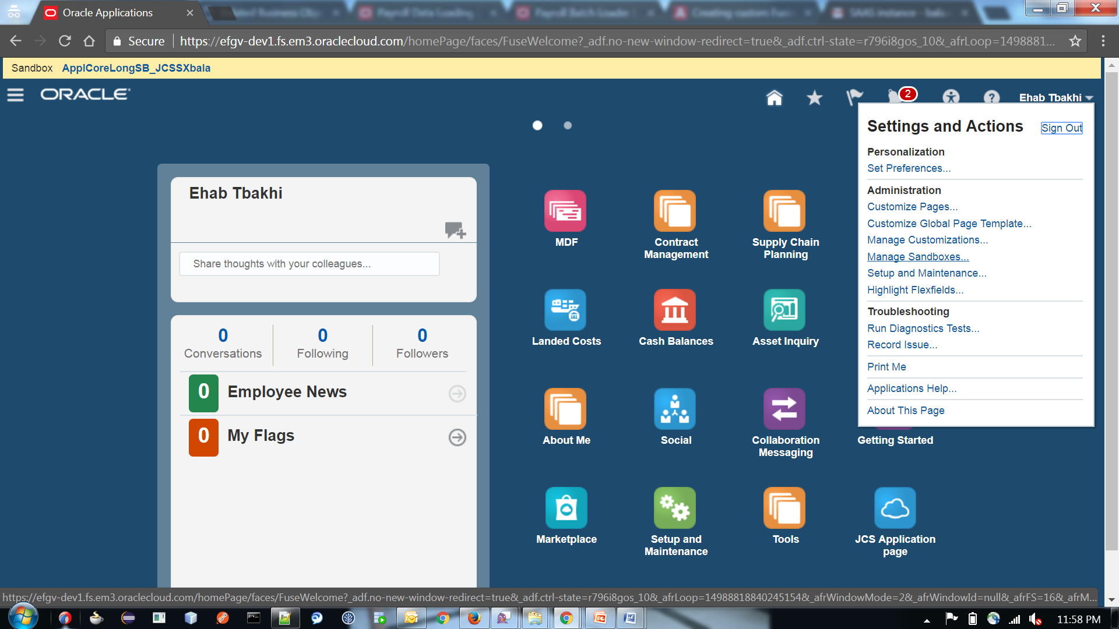

Then click Add New Sandbox and create on clicking Save and close.

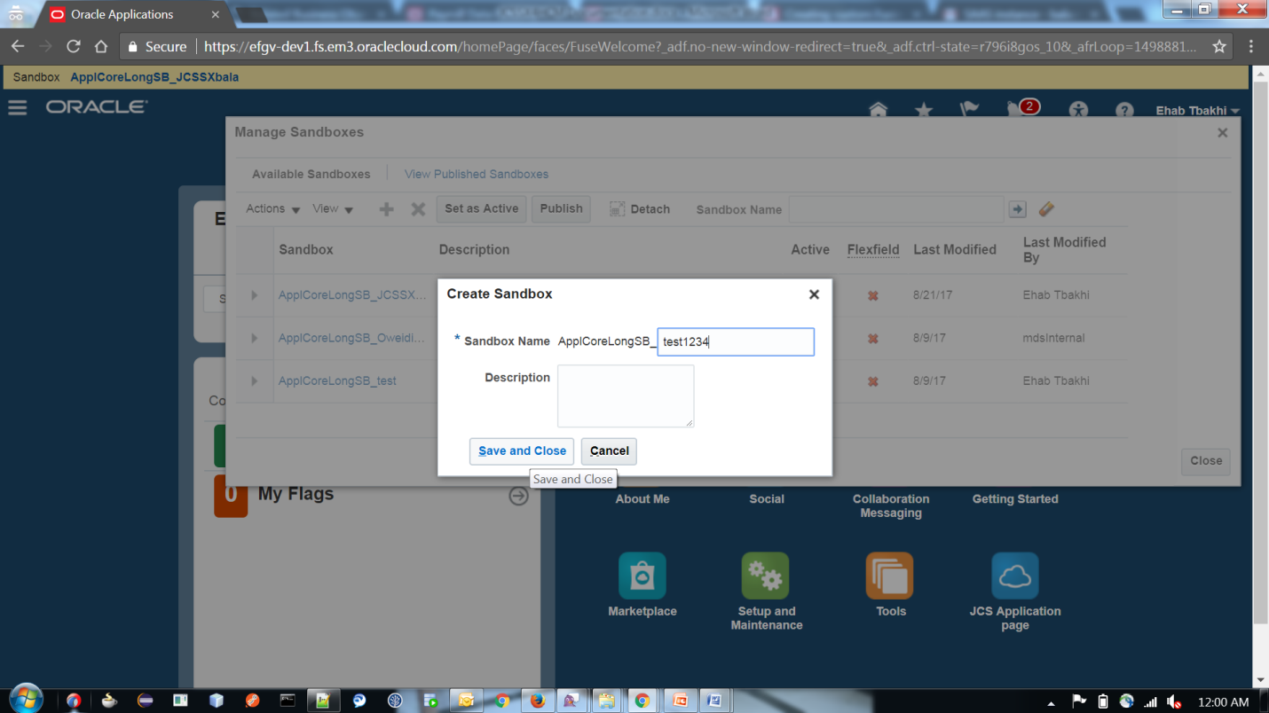

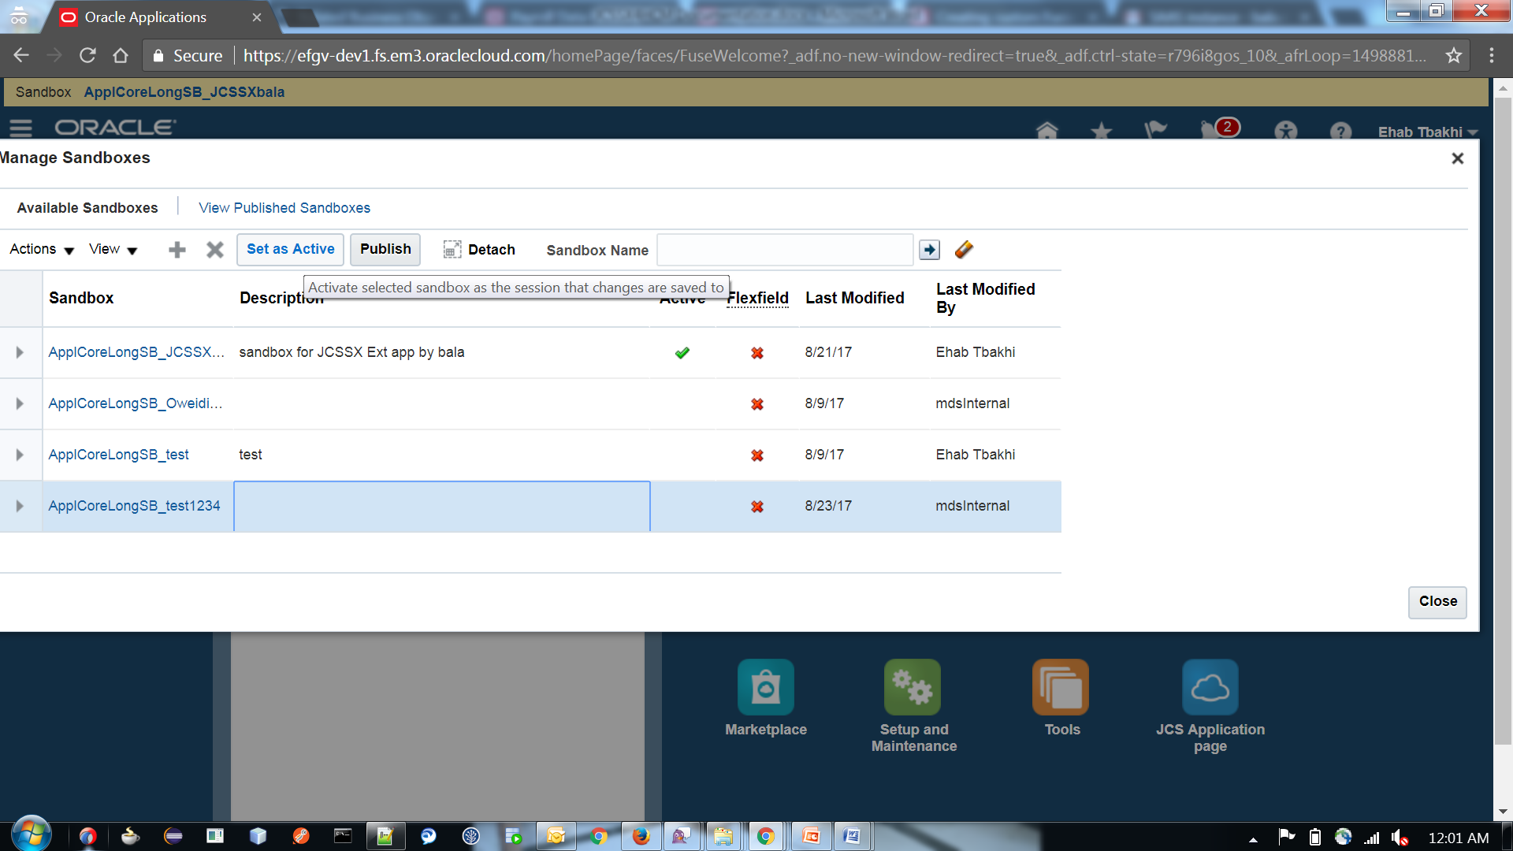

Then select the sandbox and click “Set as Active”

Now in Home Screen :

In Sandbox session, Go to navigator > Setup and Maintenance

Then click “Manage Custom Setup Content” on Tasks tab .

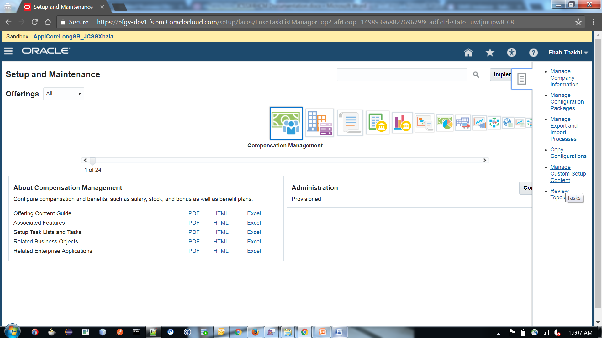

Then click Manage Third Party Applications under Topology Definition.

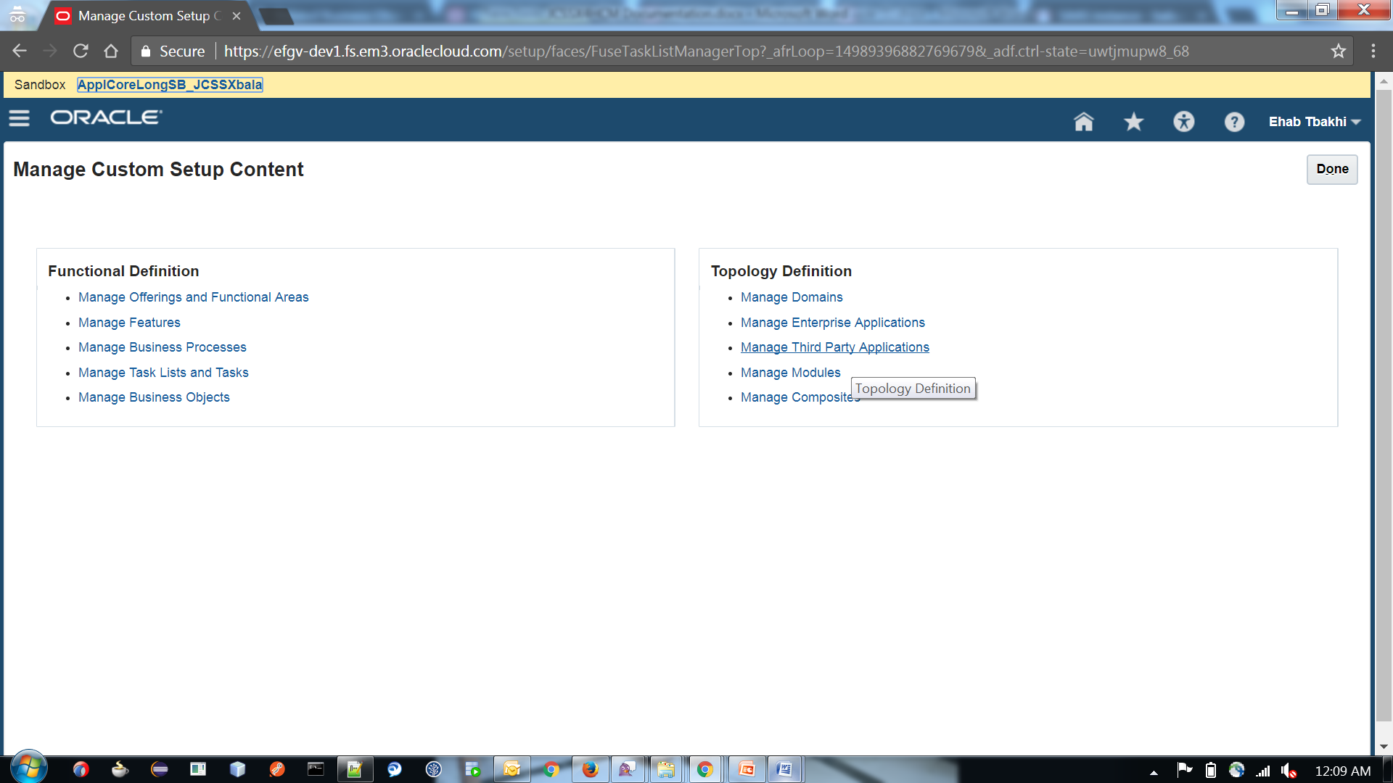

Then Click Create New icon under search results

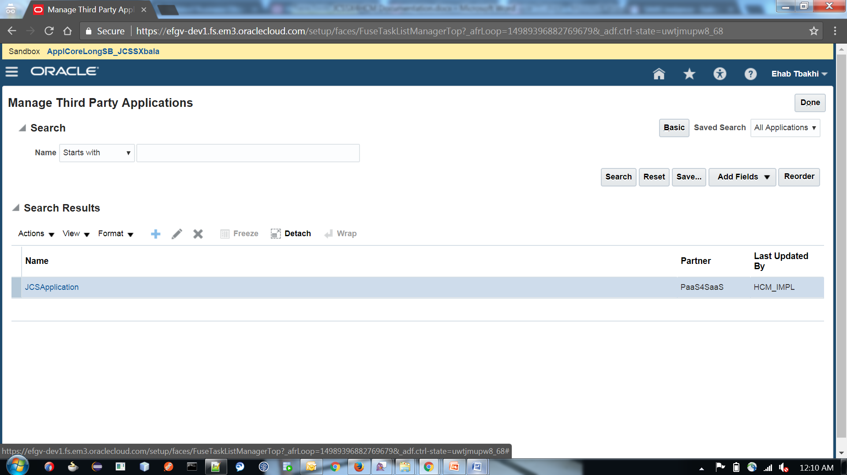

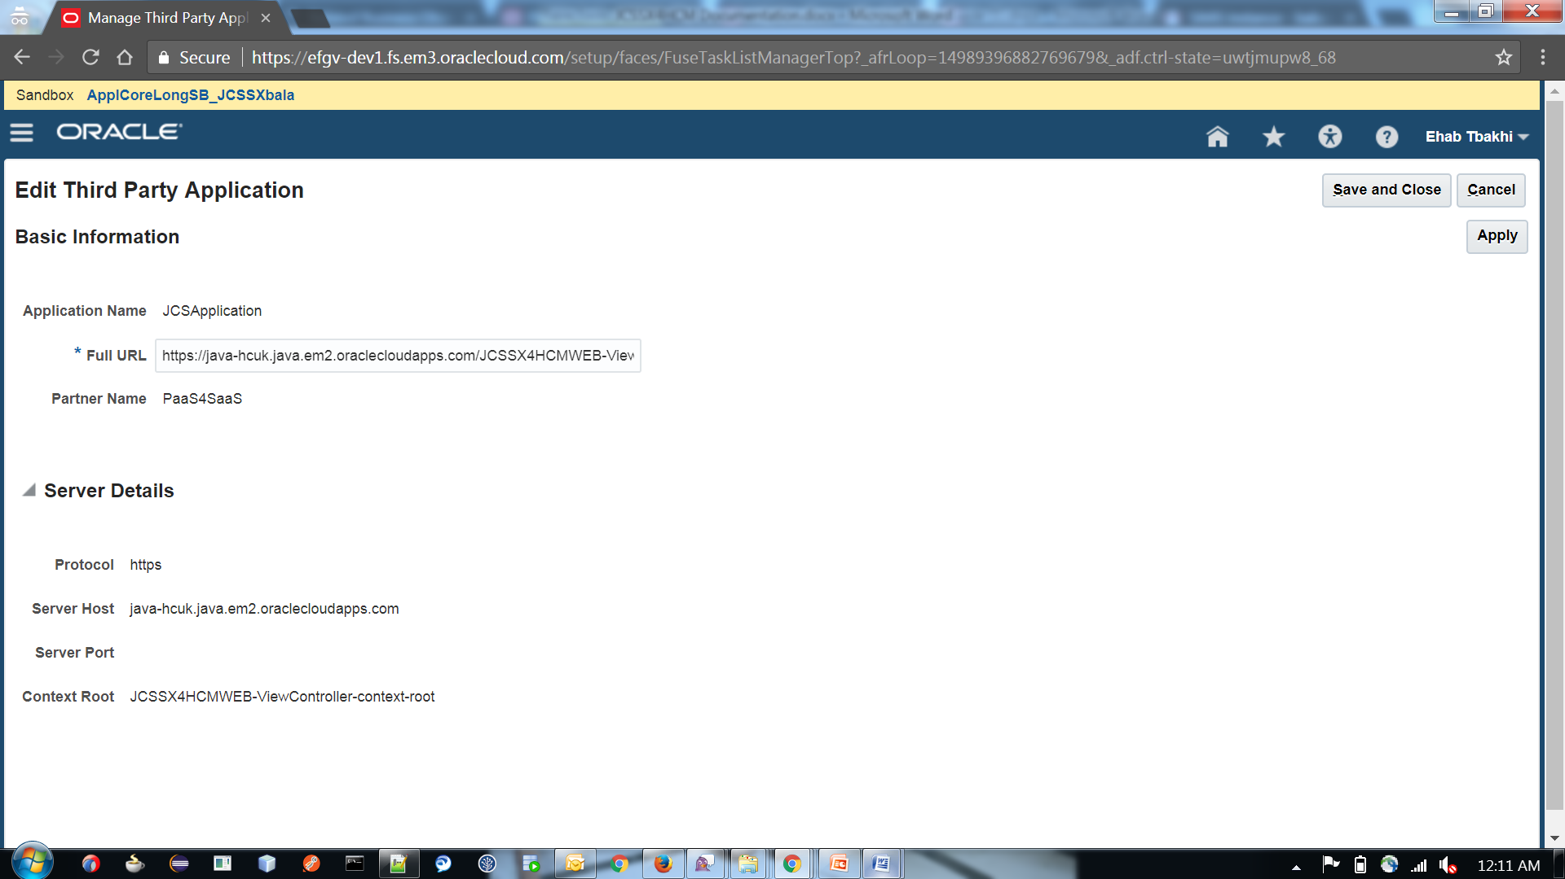

Fill the details as per above screen. Use “https://java-hcuk.java.em2.oraclecloudapps.com/JCSSX4HCMWEB-ViewController-context-root” for Full URL. Then Save and Close. Then Done.

Now

Click on Navigator > Tools > Structure

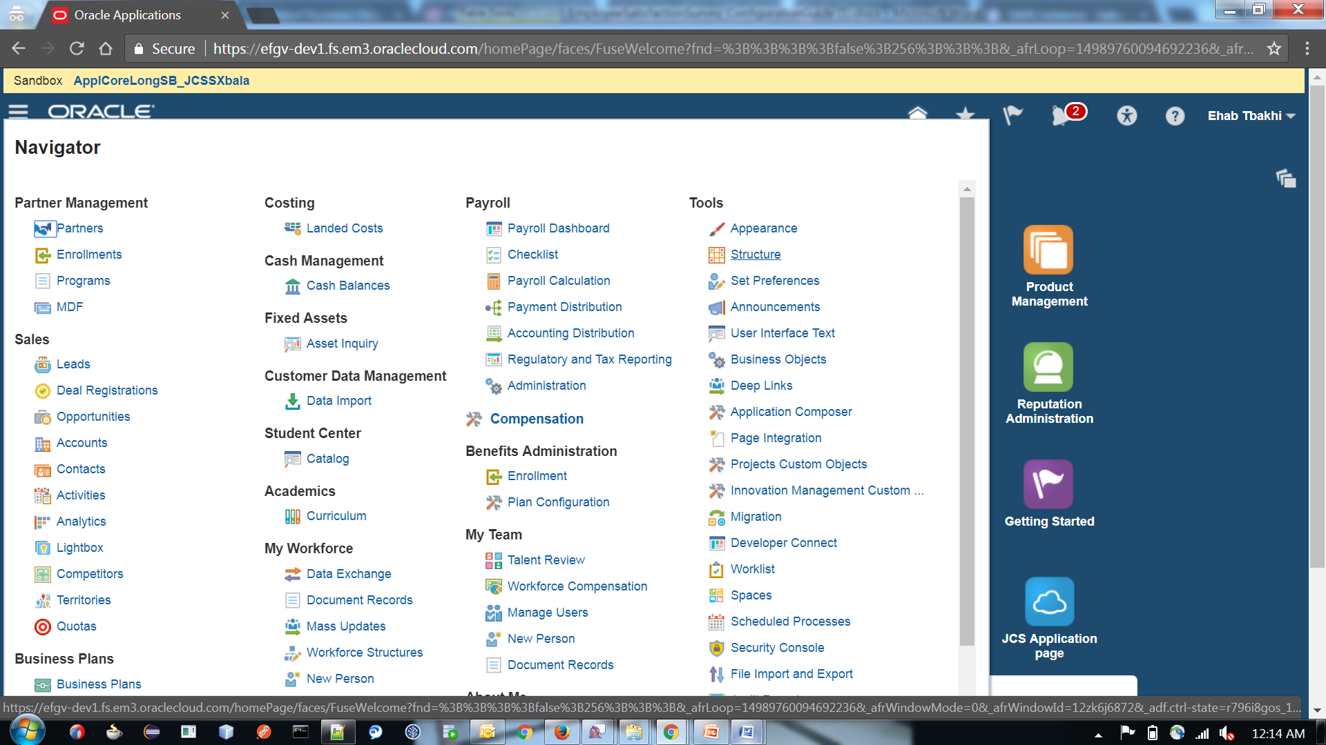

Then Click create Category

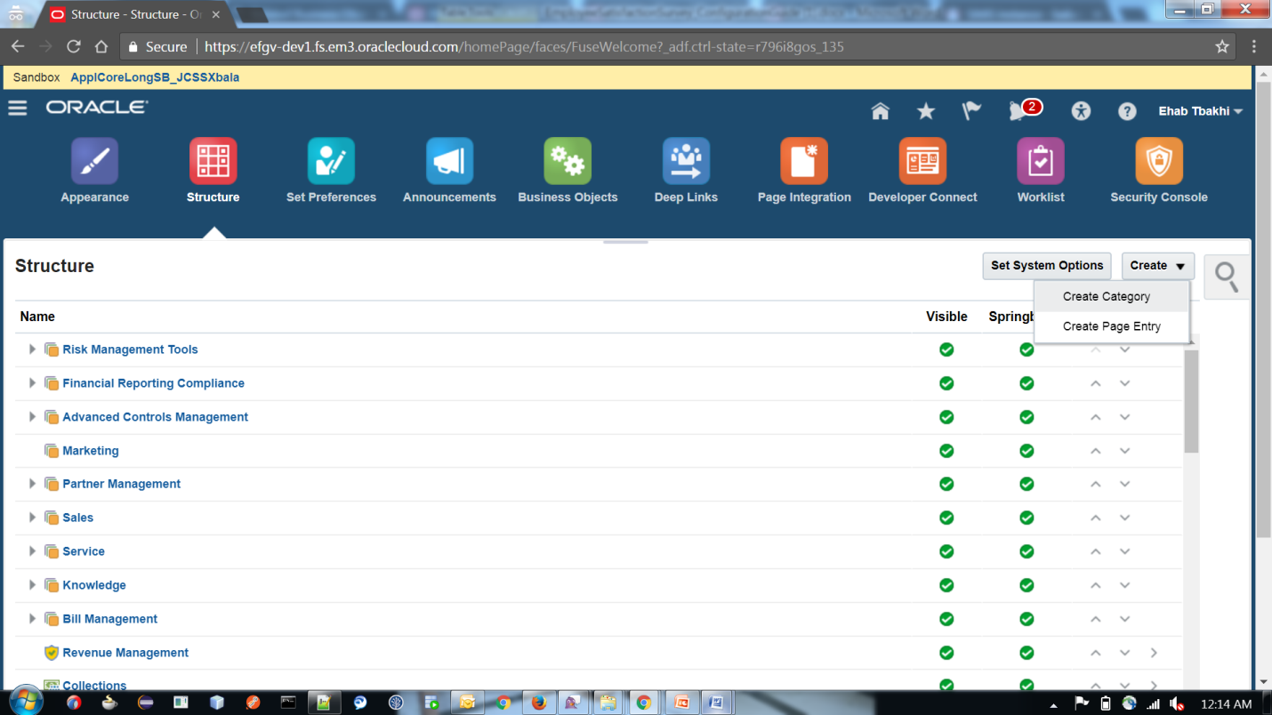

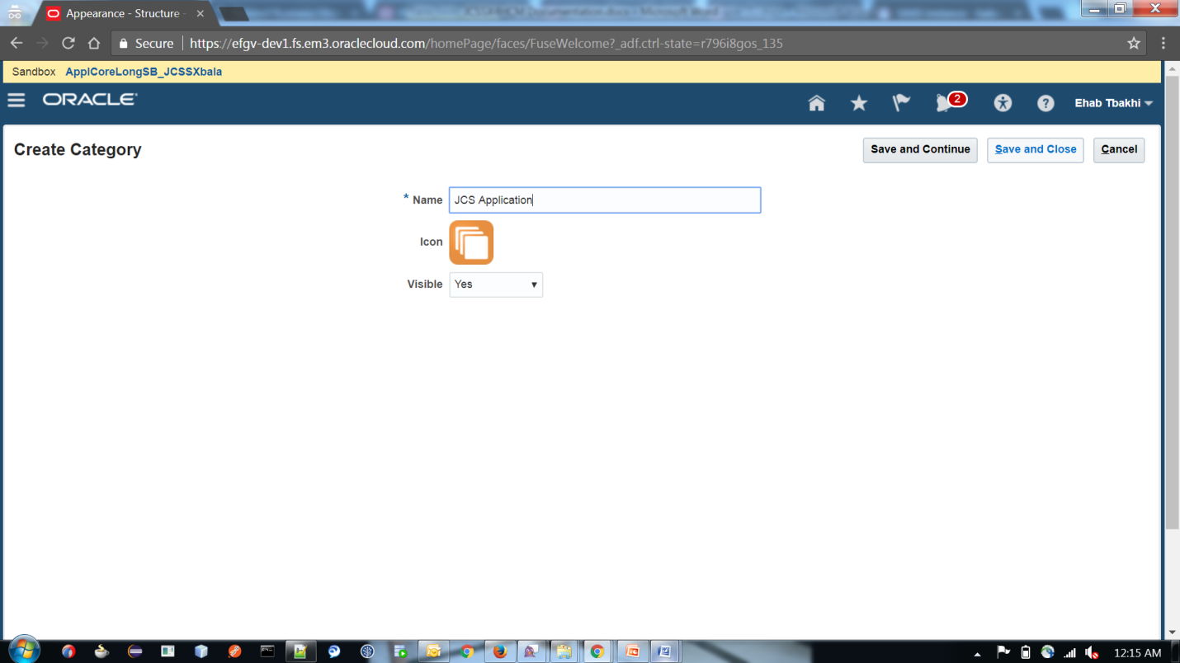

Now click Create Page Entry :

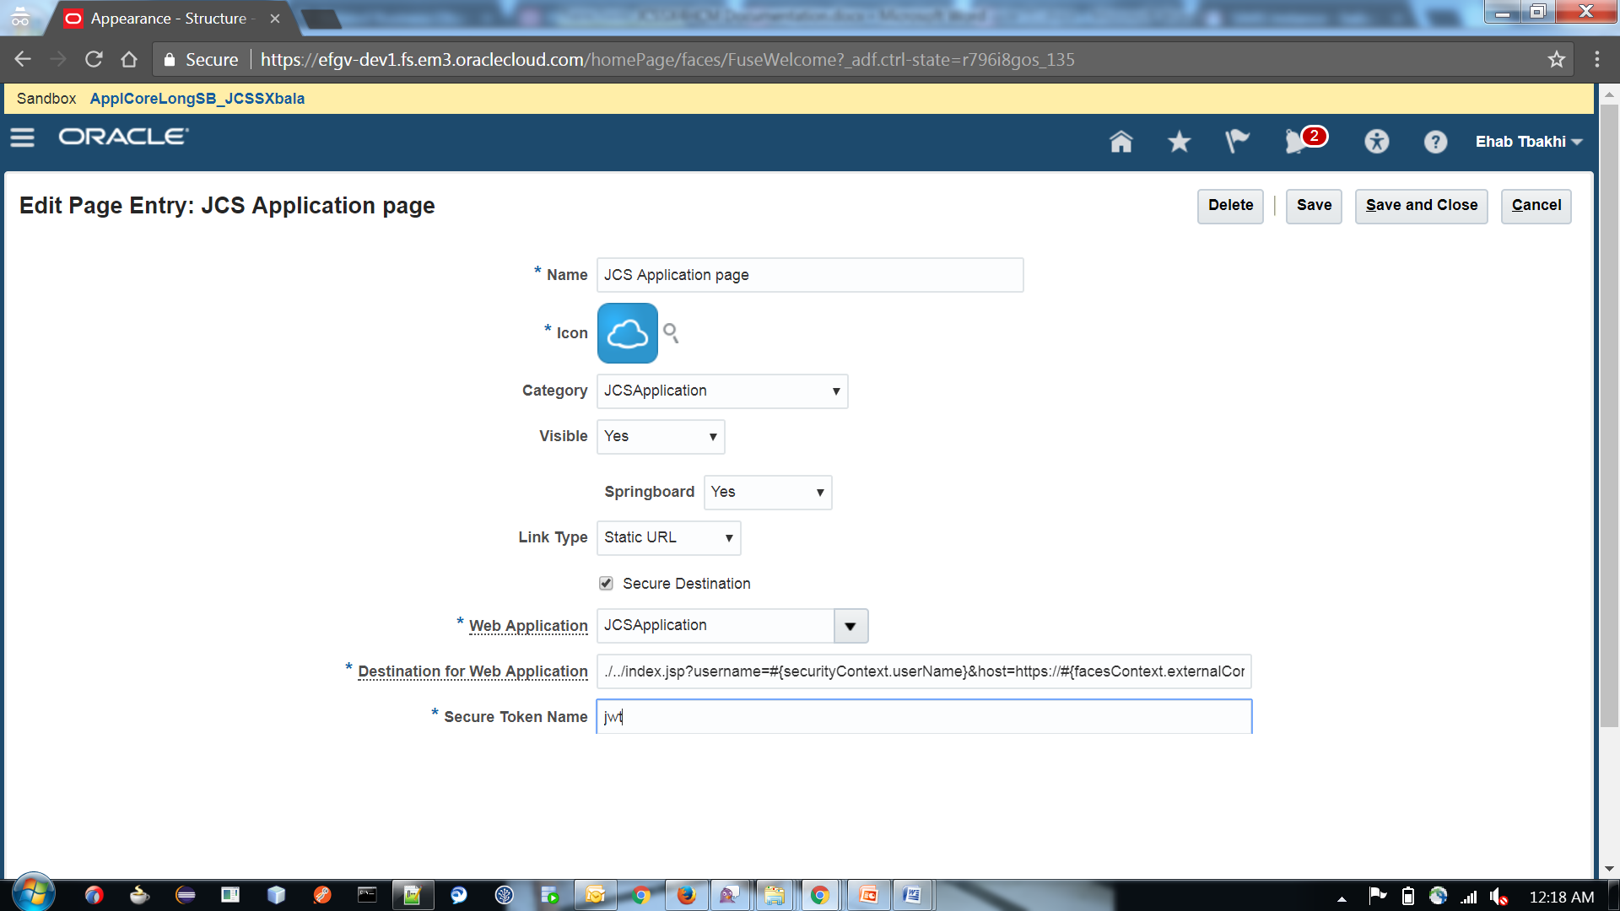

Enter “./../index.jsp?username=#{securityContext.userName}&host=https://#{facesContext.externalContext.request.serverName}” in destination for web application.

And other details as above. Then click Save and Close.

Now verify if the Icon is present in Home Screen

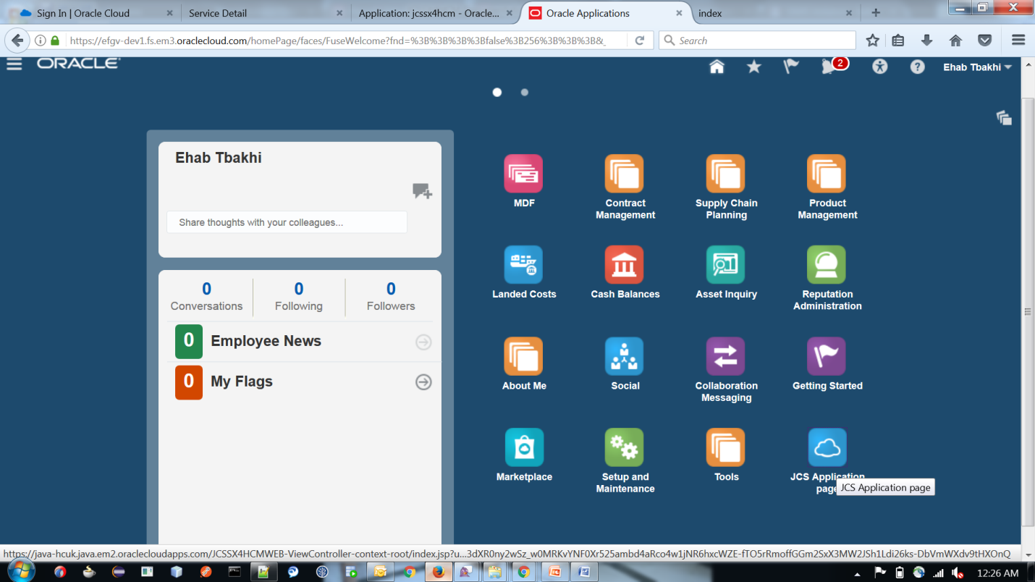

Click JCS Application Page icon and it should take us to our application page.

